UCF Student Help Guide
Online Intent to Graduate Form

Log in to myUCF >Student Self Service>Graduate Students

Choose “Intent to Graduate: Apply” from drop down box

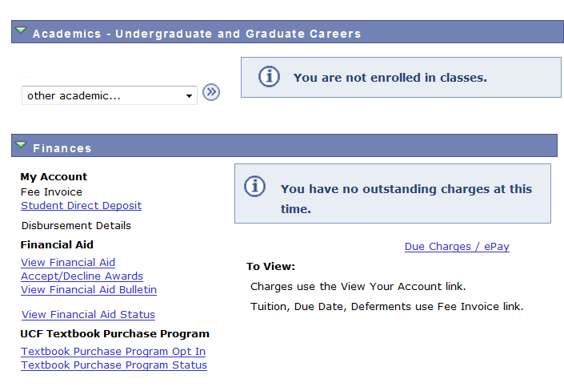
Select an Academic Program

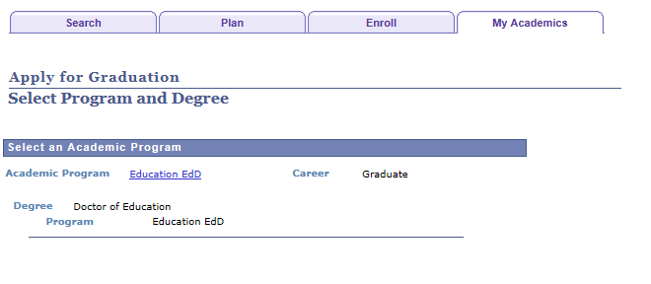
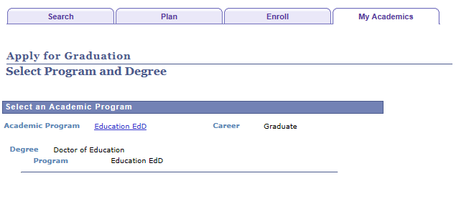

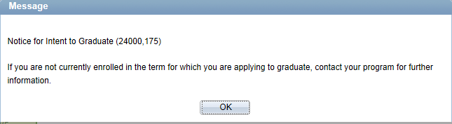

Click on OK button

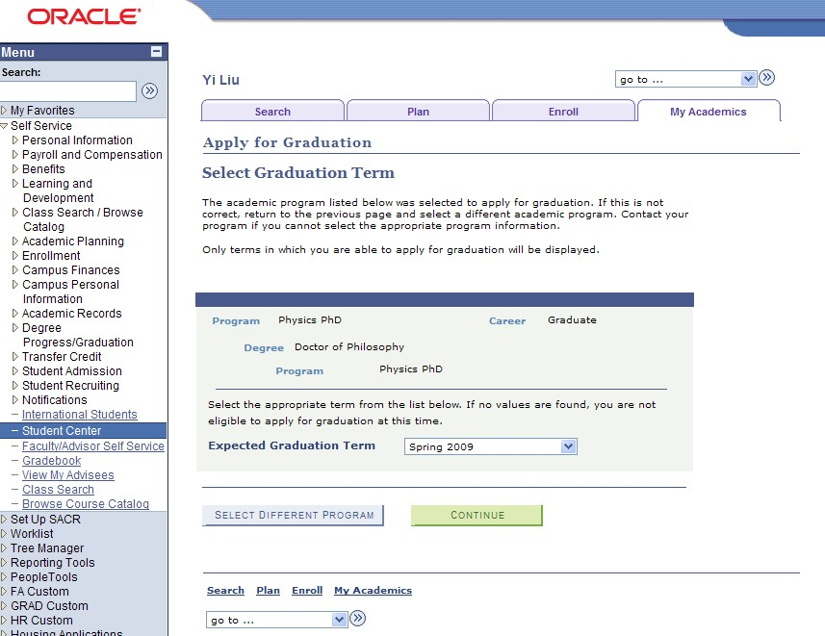
Choose Term and click continue
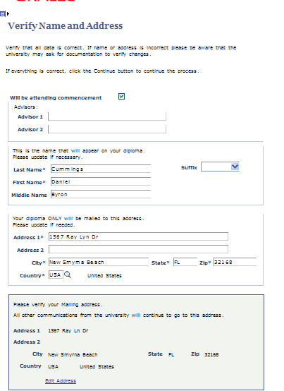
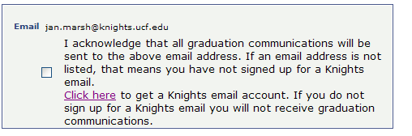

Check box if attending ceremony

List chair/co-chair of committee (doctoral) or advisor(s)
for master’s thesis and educational specialists.

Diploma name

Diploma mailing address

Mailing address

Must check box to continue to next page

If you are a doctoral candidate or educational specialist candidate, neither box is checked

Verify information and click “Continue” button
Click on survey(s) to complete
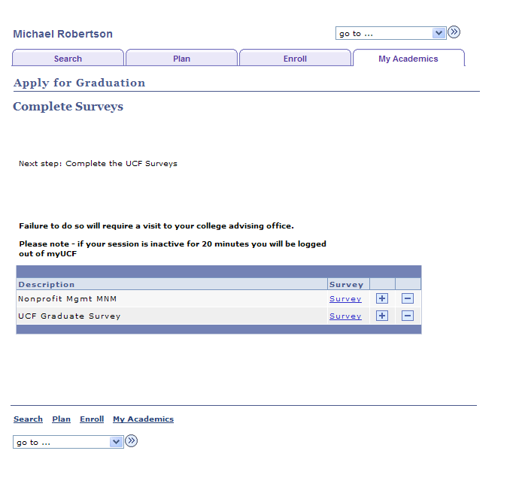

Surveys can be accessed after Online Intent to Graduate Form is submitted.

Log in to myUCF

Choose “Intent to Graduate: Survey” from drop down box

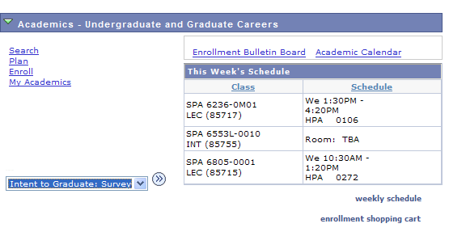
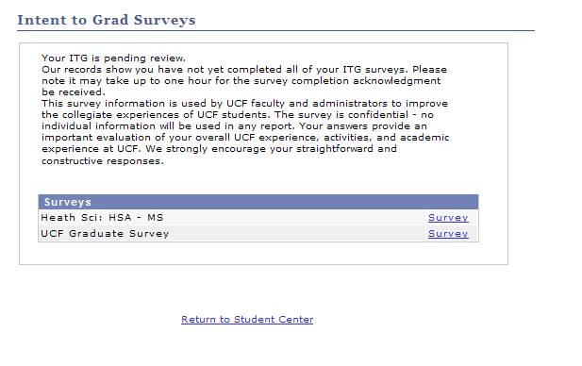
Choose appropriate survey (s) to complete

Not eligible to file ITG

This message will appear if you are not active in a program or have already filed and Intent to Graduate Form for the
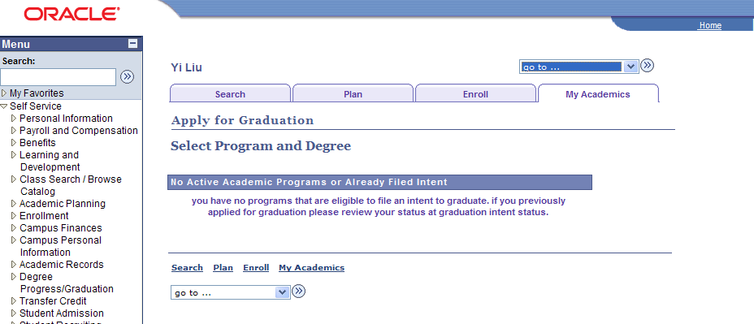
current term.

Student Review Intent to Graduate on myUCF

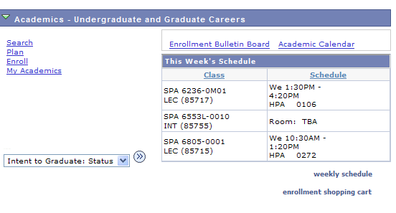
Choose “Intent to Graduate: Status” from drop down box

